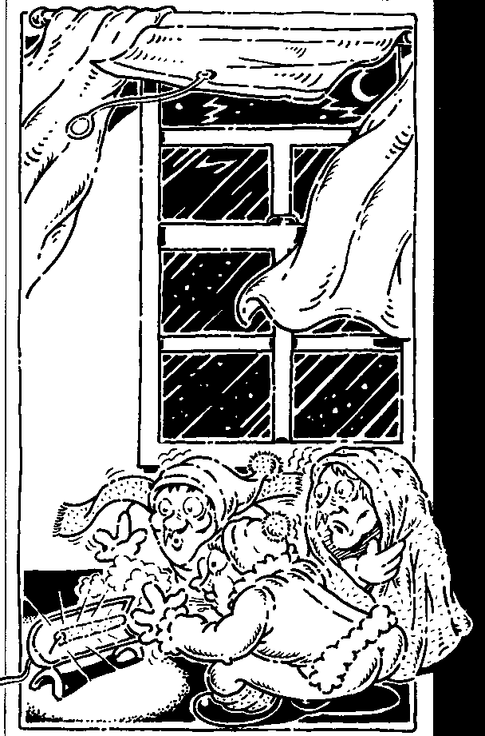
Heat Energy

What is heat?

Heat is the name given to energy that moves from a hotter object to a cooler one. The particles in both the hotter and cooler objects are moving and so have kinetic energy, but the particles in the hotter object have more kinetic energy than the particles in the cooler object. The movement of heat energy stops when the temperature of each object becomes the same. Temperature is a measure of how much kinetic energy the particles in an object possess.

60⁰C
heat
flow
air
10⁰C
30⁰C
no
heat
flow
air
30⁰C

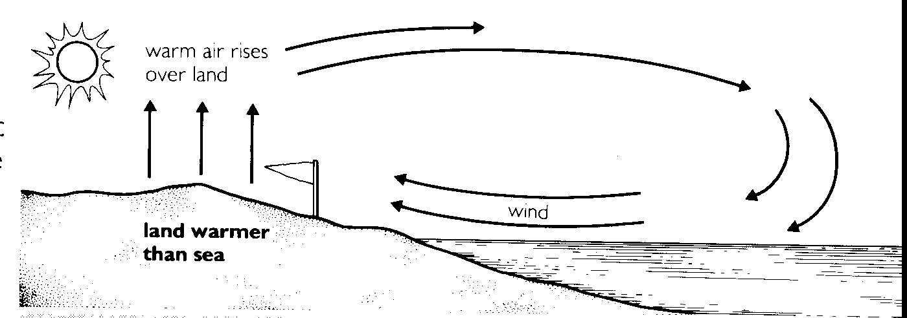

Transferring heat energy
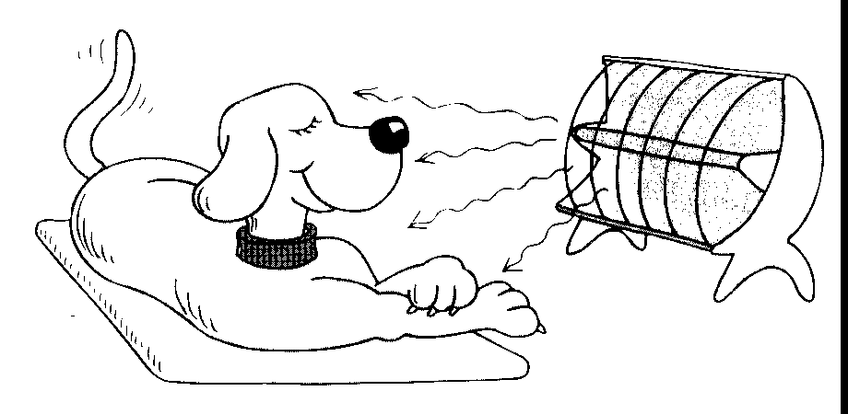

Three methods by which heat energy moves from one place to
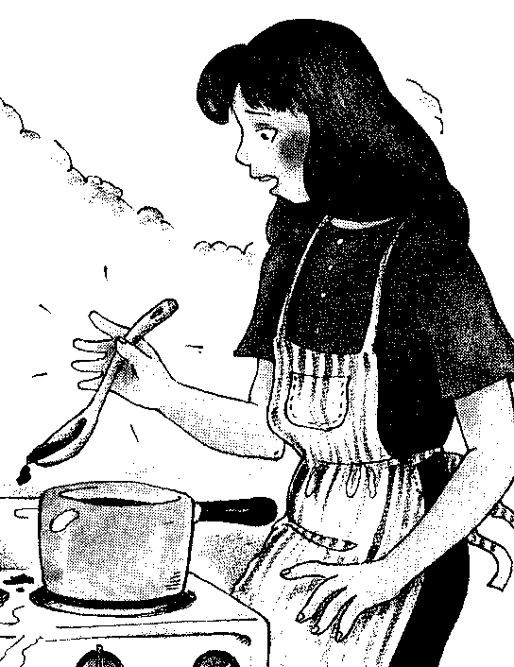
another are conduction, convection and radiation.

Conduction

1. Carry out the following experiment

a) Set up the following equipment
copper rod
toothpicks in wax
HEAT
clamp and stand

b) Heat one end of the rod and note the order in which the toothpick fall?

2. Use the following diagram to explain how the heat moved by conduction through the copper rod.
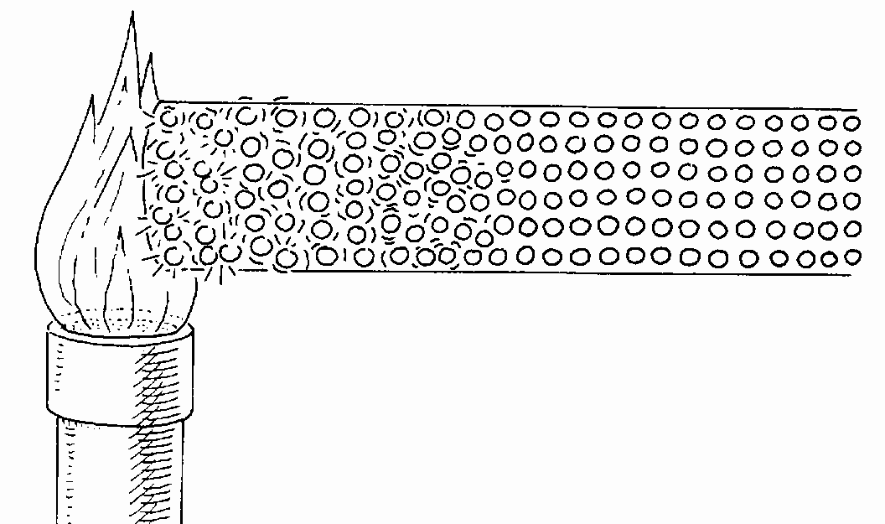

3. Not all materials are good conductors of heat.
a) What name is given to materials that are not good conductors of heat?
b) Give some examples of good conductors of heat and of poor conductors of heat.

4. List five ways in which conductors and/or insulators are used by you or your family.

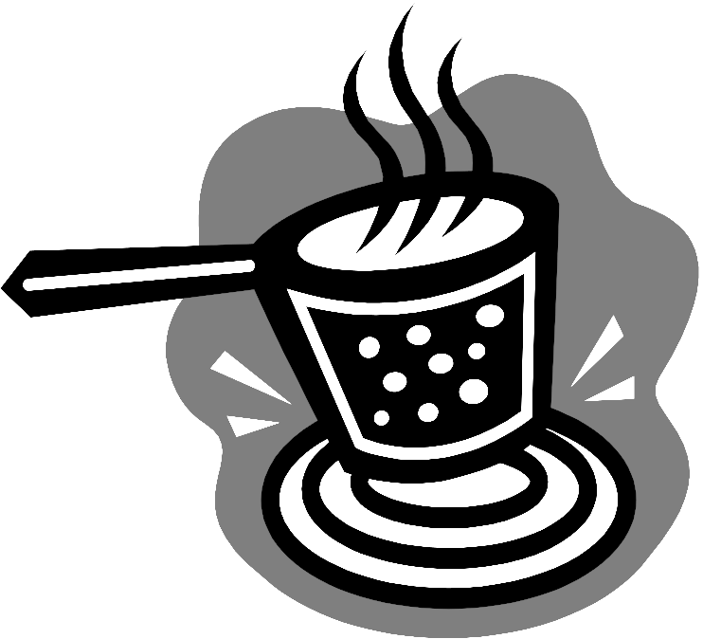

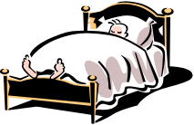

Convection

5. Carry out the following experiment:

Set up the equipment shown in the diagram on the right.
a) Draw the path of the purple colour .
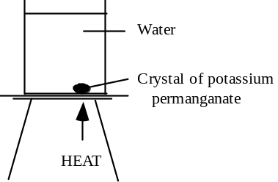
b) Why does the purple colour follow this path?



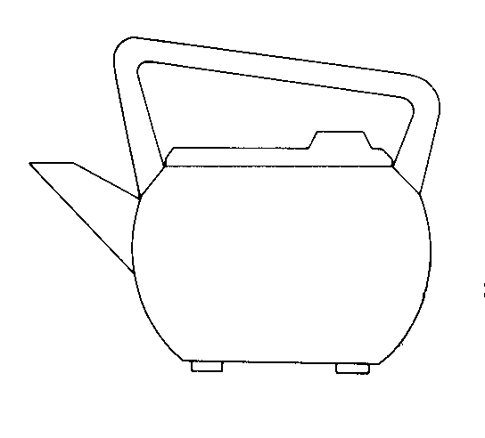

6. Show where would you place the heating element in an electric kettle. Explain your answer.

Radiation

7. Using a black can, a silver can and a radiator, carry out an experiment to show which colour, black or silver is the best absorber of radiant heat energy.
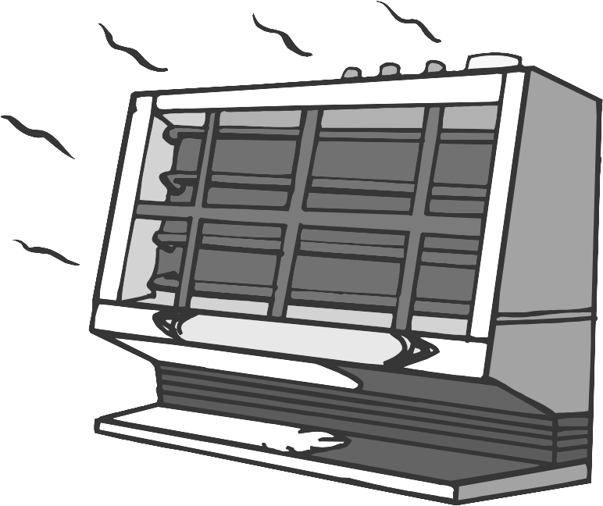

Record the method you used and your results.

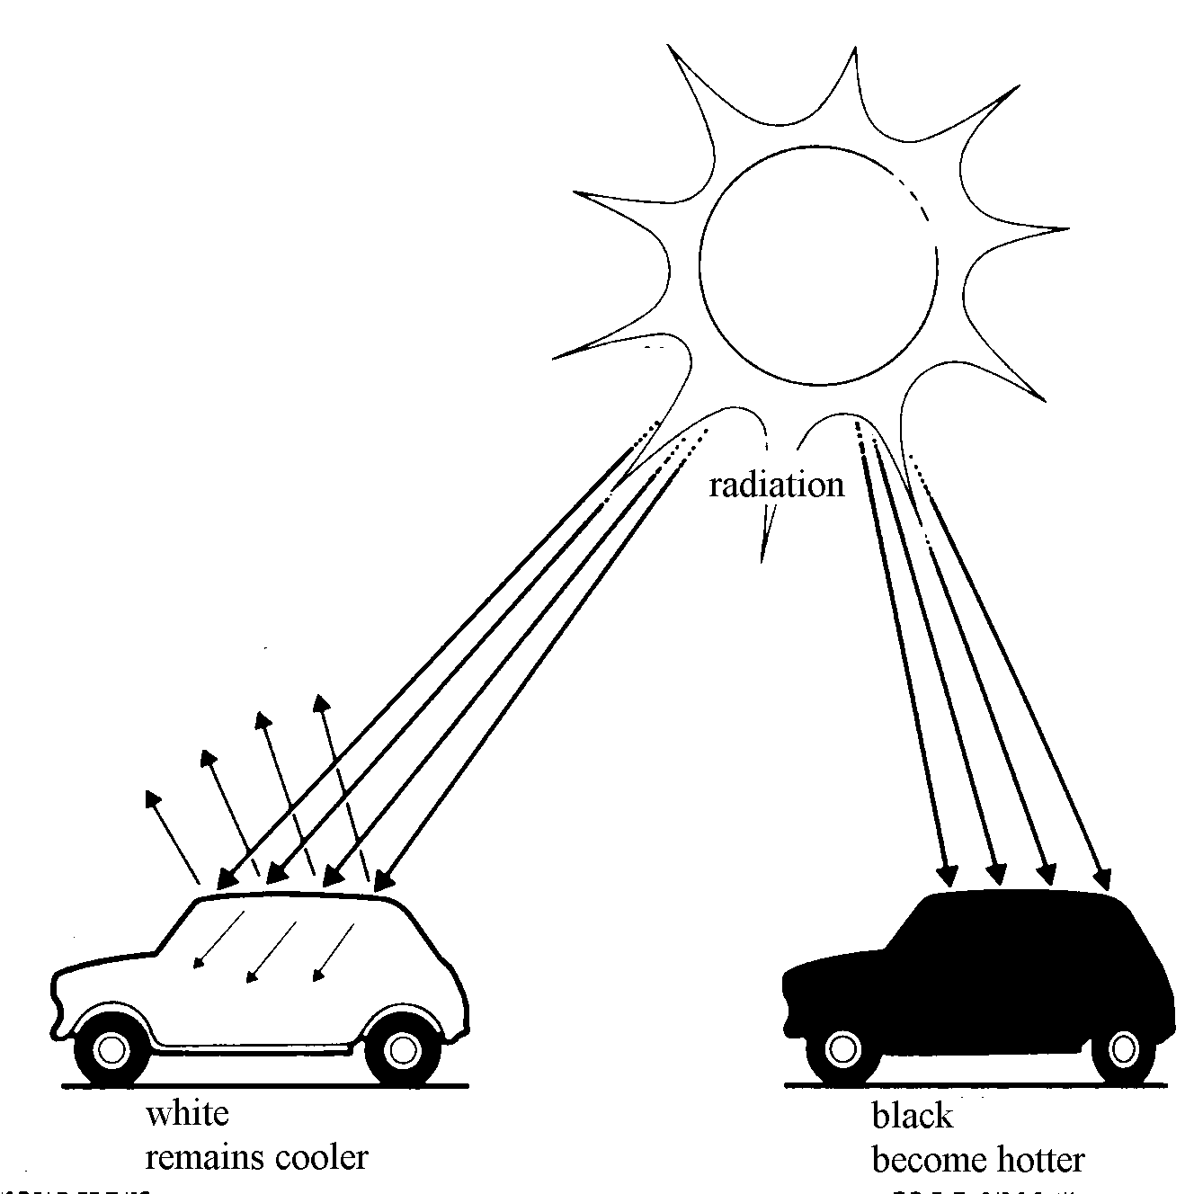
8. a) Which colour, silver or black, is the best radiator of heat?

b) List some items which are painted this colour so they can quickly lose heat.



9. Why do people playing cricket or tennis usually wear light coloured clothes?

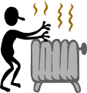

How do we use heat energy?

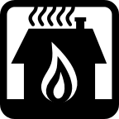
10. List the ways in which we use heat energy.



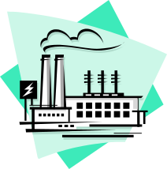

11. Choose TWO of the uses. Describe, in as much detail as possible, the energy flow involved in each of the uses.



